Let's continue with the Medical Inquiry agent. Let's refactor the requirements document, Architecture, solution design, tech stack, production deplyoment. Keep in mind we will use Anthropic's Agent Development Platform, and deploy this on Google Cloud.
Production Deployment & Blueprint
The blueprint leverages Claude Managed Agents inside the Anthropic Console, paired with Google Cloud Platform (GCP) for strict data isolation and enterprise system connectivity.
This setup removes the need for manual agent-loop orchestration. Instead, it pairs Anthropic’s managed runtime with Google Cloud's data governance frameworks.
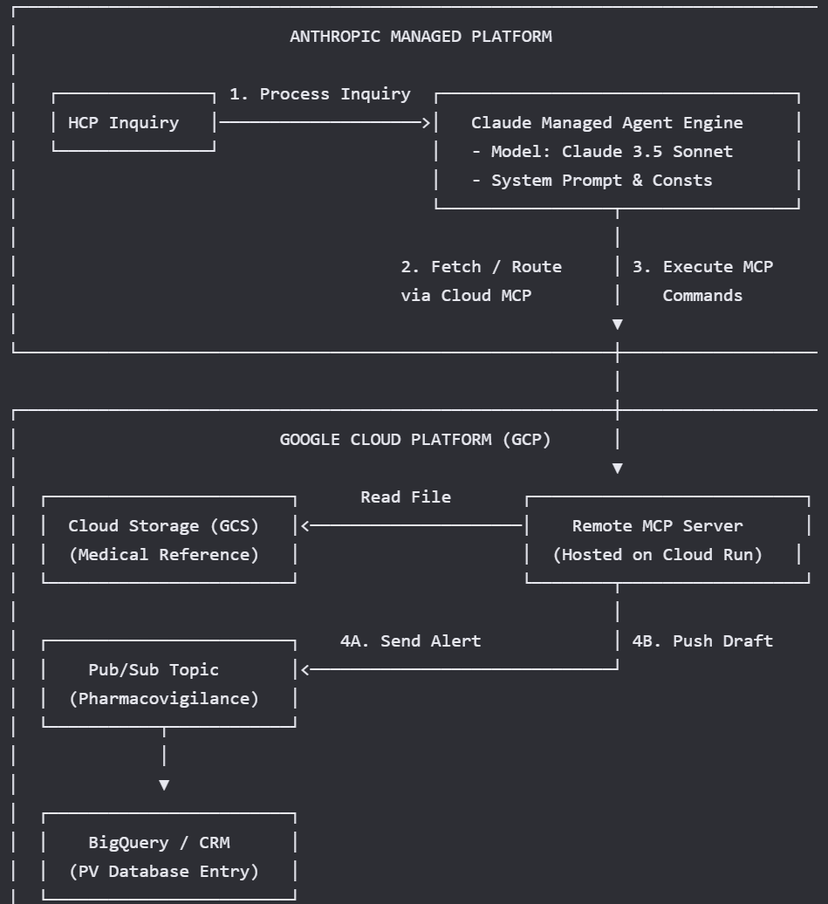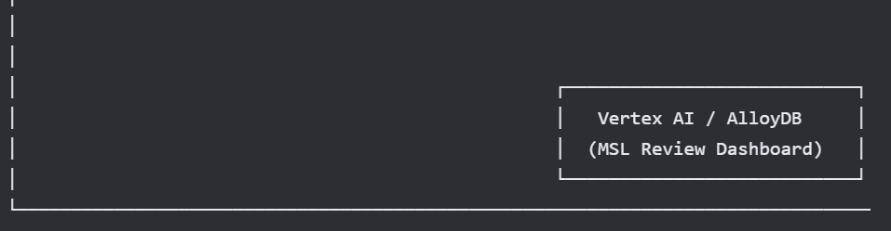

1. Requirements Document (BRD / FRD)
Business & Operational Objectives
- Response Automation: Reduce response times for standard Medical Science Liaison (MSL) inquiries from days to minutes.
- Pharmacovigilance Compliance: Identify Adverse Events (AEs) with zero tolerance for failure, routing them to corporate safety within 24 hours.
- Zero Hallucination Tolerance: Restrict responses exclusively to facts found in verified medical literature.
Functional Requirements
- Ingestion: Accept text-based medical inquiries from CRM systems (e.g., Veeva) or official medical dropboxes.
- Classification: Isolate the drug name, separate standard inquiries from off-label requests, and audit for potential AEs.
- Grounded Synthesis: Automatically index and retrieve context from local medical PDFs to generate formal response drafts.
- Strict Citation Mapping: Map every generated clinical claim back to its exact page and document source.
Security & Compliance Requirements
- Data Privacy: Ensure no input text or reference PDFs are used for external model training.
- Audit Trail: Maintain immutable logs of every user input, agent decision, retrieved source text, and final output.

2. Architecture & Solution Design
Ingestion & Pre-Processing
- Inquiries enter the system and pass to the Claude Managed Agent Engine.
- The model executes a single-turn structured analysis step using strict schema outputs to confirm if an adverse event occurred or if the query involves off-label usage.
Data Sovereignty & Document Storage
- To ensure proper document management on Google Cloud, reference PDFs are saved in a protected Google Cloud Storage (GCS) bucket.
- Document access is handled through a remote Model Context Protocol (MCP) Server running on Google Cloud. Rather than uploading data into a shared multi-tenant space, the agent uses secure MCP commands to scan and retrieve files on demand.
Safety & Routing Logic (The Switchboard)
- Path A (Adverse Event Identified): The agent halts standard drafting and uses an MCP call to push data to a GCP Pub/Sub topic. This topic immediately triggers a priority entry in the corporate Pharmacovigilance tracking system.
- Path B (Standard/Off-Label Medical Query): The agent gathers text from the GCS bucket via the MCP connector, generates a structured response draft, and appends explicit reference citations.

3. Tech Stack
Component | Technology Variant | Selection Rationale
Agent Engine | Anthropic Managed Agents Platform | Provides a managed runtime environment, prompt caching, and persistent session states without infrastructure maintenance.
Foundation Model | Claude 3.5 Sonnet | Offers accurate multi-document analysis, reliable tool execution, and clear formatting.
Infrastructure / Cloud | Google Cloud Platform (GCP) | Standard corporate cloud infrastructure providing encryption at rest and in transit.
Document Storage | Google Cloud Storage (GCS) | Offers secure object storage for medical manuals and PDFs.
Agent Interactivity | Model Context Protocol (MCP) | Anthropic's open standard for secure tool execution and internal file system retrieval.
Integration Layer | GCP Cloud Run | Used for hosting the remote custom MCP server securely within your VPC.
Message Broker | GCP Pub/Sub | Guarantees downstream processing for critical compliance routing.

Testing Your No-Code Agent
Anthropic's console features a built-in Workbench and Evaluation tool. Before pushing this agent live to your Medical Affairs team, you can run rigorous test scenarios: [1, 2]
- Click on the Evaluations tab.
- Create test input columns (e.g., Column A: HCP Inquiry).
- Enter test scenarios to evaluate accuracy:
  - Test 1 (Adverse Event): "A patient taking our drug is experiencing severe nausea. Can we reduce the dose?"
  - Test 2 (Off-Label): "Can this adult medication be prescribed to a 5-year-old child?"
- Run the evaluation suite. You can visually compare Claude's drafted outputs side-by-side to verify that inline citations are mapping perfectly to your uploaded PDFs, and that the Pharmacovigilance alerts trigger correctly. [1, 2]

Future Phases
- Would you like to review the specific evaluation strategies (RAGAS or Claude-driven auditing) to prove to compliance that this agent does not hallucinate?
- Do you want to know more about how to set up the automated guardrails inside one of these specific tools?
- Do you want to see an example of how to format the System Prompt specifically for off-label inquiries?
- Would you like guidance on setting up user roles so only specific MSLs can access this console project?
- Should we map out how the human-in-the-loop approval step looks before the draft is emailed back to the HCP?
- Would you like to review a sample Python file for the actual MCP Server code to see how it takes Claude's request and reads from Google Cloud Storage, or should we look at designing the MSL human-in-the-loop dashboard?

Steps

Step 1: Initialize the GCP Environment & Deploy the Custom MCP Server

1. Configure Google Cloud Storage (GCS)
Create a secure bucket in your project, enable uniform bucket-level access control, and upload your local medical literature files:
gcloud storage buckets create gs://pharma-medical-reference-docs \
--region=us-central1 \
--project=medical-inquiry-agent

gcloud storage buckets update gs://pharma-medical-reference-docs \
--uniform-bucket-level-access \
--project=medical-inquiry-agent

gcloud storage cp ./*.pdf gs://pharma-medical-reference-docs/ \
--project=medical-inquiry-agent

2. Create the Private Artifact Registry Repository
Establish a modern Docker repository to house your agent container images securely:
gcloud artifacts repositories create pharma-agents \
--repository-format=docker \
--location=us-central1 \
--description="Docker repository for medical affairs agents" \
--project=medical-inquiry-agent

3. Bind Service Account IAM Permissions
Grant the default Cloud Build runtime service account the necessary access rights to write logs, read your source code files, and push the final image to Artifact Registry:
gcloud projects add-iam-policy-binding medical-inquiry-agent \
--member="serviceAccount:924862468099-compute@developer.gserviceaccount.com"\
--role="roles/storage.objectViewer"

gcloud projects add-iam-policy-binding medical-inquiry-agent \
--member="serviceAccount:924862468099-compute@developer.gserviceaccount.com"\
--role="roles/artifactregistry.writer"

gcloud projects add-iam-policy-binding medical-inquiry-agent \
--member="serviceAccount:924862468099-compute@developer.gserviceaccount.com"\
--role="roles/logging.logWriter"

4. Compile and Build the Container Image
Submit your source directory to Google Cloud Build to create your custom Model Context Protocol (MCP) server container image:
gcloud builds submit \
--tag us-central1-docker.pkg.dev/medical-inquiry-agent/pharma-agents/medical-mcp-server:v1 \
--project=medical-inquiry-agent

5. Deploy the Server to Google Cloud Run
Deploy the compiled container image to Cloud Run. This restricts public traffic by requiring authenticated tokens (--no-allow-unauthenticated) and sets the required environment variables:
gcloud run deploy medical-mcp-server \
--image us-central1-docker.pkg.dev/medical-inquiry-agent/pharma-agents/medical-mcp-server:v1 \
--platform managed \
--region us-central1 \
--no-allow-unauthenticated \
--project=medical-inquiry-agent \
--set-env-vars="GCP_PROJECT_ID=medical-inquiry-agent,GCS_BUCKET_NAME=pharma-medical-reference-docs"

Verified Output Link:
Great work! Your secure MCP server is now live and protected inside your Google Cloud VPC at:
https://medical-mcp-server-924862468099.us-central1.run.app

Step 1 completed: Initialize the GCP Environment & Deploy the Custom MCP Server

